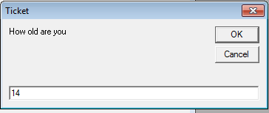Private Sub Run_Click()

Dim ticket As Single

Dim total As Single

ticket = InputBox("How old are you")

If ticket <= 12 Or ticket >= 64 Then

total = 8 * 1.13

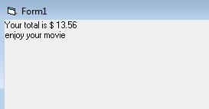Else: total = 12 * 1.13

End If

Print "Your total is $"; total

Print "enjoy your movie"

End Sub